**A Joint Symposium of**

**South China Sea Institute of Oceanology and**

**IODP-China**



***The Evolution of Oceanic Lithosphere and Formation of Marginal Seas Lecture Series***

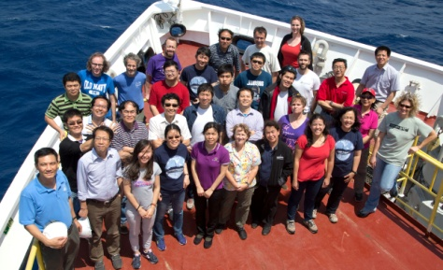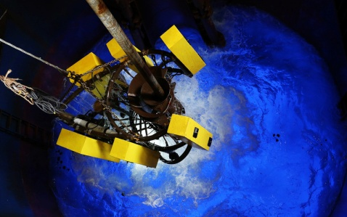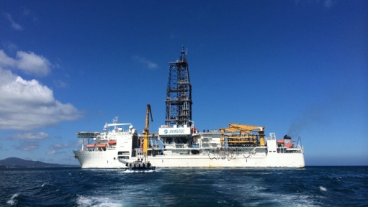

**Symposium Title**

**Magma-poor & Magma-rich Margins: Structure and Evolution**

**Guangzhou**

**October 24-26, 2016**

**Schedule**

**October 24, 2016 Monday**

|  |  |  |
| --- | --- | --- |
| **Time** | **Title** | **Speaker** |
| **Morning – Moderator：Zhen Sun** | | |
| **08:30-09:00** | Welcome and science introduction | Jian Lin |
| **09:00-09:30** | The general importance and fundamental questions related to rifted margins | Hans Christian Larsen |
| **09:30-10:00** | Photo session + Tea break | |
| **10:00-12:00** | Structures and evolution of magma-poor continental margins | Tim Reston |
| **12:00-12:30** | Seismic studies of accretion of oceanic lithosphere in magma-rich EPR and magma-poor MAR | Min Xu |
| **12:30-14:00** | Lunch | |
| **Afternoon – Moderator：Xuelin Qiu** | | |
| **14:00-16:00** | Up- and down-scaling field and seismic observations to test models of hyperextended rifted margins | Gianreto  Manatschal |
| **16:00-16:30** | Tea break | |
| **16:30-17:00** | Post-spreading volcanism in the South China Sea | Minghui Zhao |
| **17:00-18:00** | Discussionon magma-poor margin + Free presentations  (5min each) | |

**October 25, 2016 Tuesday**

|  |  |  |
| --- | --- | --- |
| **Time** | **Title** | **Speaker** |
| **Morning – Moderator：Jian Lin** | | |
| **08:30-09:30** | Large Igneous Provinces (LIPs): Origin, expressions and impact | Hans Christian Larsen & Mike Coffin |
| **09:30-10:30** | Controls on structural and magmatic variability along rifted margins: from observations to interpretations **–** 1 | Gianreto  Manatschal |
| **10:30-10:45** | Tea break | |
| **10:45-11:45** | Controls on structural and magmatic variability along rifted margins: from observations to interpretations **–** 2 | Gianreto  Manatschal |
| **11:45-12:30** | The Norwegian volcanic rifted margin | Hans Christian Larsen &  SverrePlanke |
| **12:30-14:00** | Lunch | |
| **Afternoon – Moderator：Minghui Zhao** | | |
| **14:00-15:00** | The southeast Greenland volcanic rifted margin | Hans Christian Larsen |
| **15:00-16:00** | When, where and how is magma emplaced in magma-rich margins | Gianreto  Manatschal |
| **16:00-16:30** | Tea break | |
| **16:30-17:00** | The magmatism and its passage in the Northern South China Sea continental margin | Shaohong Xia |
| **17:00-18:00** | Discussionon magma-rich margin + Free presentations  (5min each) | |

**October 26, 2016 Wednesday**

|  |  |  |
| --- | --- | --- |
| **Time** | **Title** | **Speaker** |
| **Morning – Moderator：Min Xu** | | |
| **08:00-10:00** | Iberia-Newfoundland research | Tim Reston |
| **10:00-10:30** | Tea break | |
| **10:30-11:30** | IODP Expedition 349 | Jian Lin |
| **11:30-12:30** | Scientific hypotheses and expected outcomes associated with IODP proposal 878-CPP | Zhen Sun |
| **12:30-14:00** | Lunch | |
| **Afternoon – Moderator：Zhen Sun/Hans Christian Larsen** | | |
| **14:00-14:30** | What are the responsibilitiesfor IODP onboard and shore-based scientists? | Zhen Sun &Hans Christian Larsen |
| **14:30-15:00** | What’s looking like if going to an IODP expedition? | Weiwei Ding |
| **15:00-18:00** | Group discussion for IODP Exp. 367/368 | |